**NGO Management**

Final Project Report

*Submitted by*

**MD KAMRUJJAMAN-26300117045**

**MD MIR HOSSAIN-26300117038**

**SOMA DAS-037**

**MD -26300117020**

**SUMAN MAITY-26300117013**

***In partial fulfillment for the award of the degree of***

**Bachelor of Technology**

**IN**

**Computer Science and Engineering**

**COLLAGE-REGENT EDUCATION AND RESEARCH FOUNDATION GROUP OF INSTITUTION**

**UNIVERSITY-MAULANA ABUL KALAM AZAD UNIVERSITY OF TECHNOLOGY,WEST BENGAL**

**Under the Supervision of**

**MR.AMARTYA GHOSH, M.Tech. Assistant Professor**

**REGENT EDUCATION AND RESEARCH FOUNDATION**

**BONAFIDE CERTIFICATE**

**Certified that this project report “DESIGN AND ANALYSIS OF CRYPTOGRAPHIC TECHNIQUE FOR** **COMMUNICATION**

**SYSTEM” is the bonafide works of “RITTICK PAUL,RAJIB SEAKH,RANJAN SARKAR,SOURAV DEY,SUMAN MAITY” who carried out the project work under my supervision**

**SIGNATURE OF HEAD**

MR. SUBHANKAR GHOSH

M,TECH,

**Professor**

**REGENT EDUCATION AND RESEARCH FOUNDATION**

**SIGNATURE OF SUPERVISOR**

MR.AMARTYA GHOSH

M.Tech.,

**Assistant Professor**

**REGENT EDUCATION AND**

**RESEARCH FOUNDATION**

**Chapter-1**

**Study of Existing system and system requirements.**

Introduction

This application is developed to manage the activity of NGO. Admin is the main user of the website who will manage every activity. This project is developed in Java and the database used here is MYSQL using MVC architecture. In the backend, we have used Servlet. Any Organization/user willing to start an NGO can use this application.

This application will replace the manual process of NGO with an automated process where the admin will manage all the process through this website. Admin can manage the Fundraisers, Campaigns and transactions.

Objective

NGO Management System is developed to replace all the manual activity through an application. Through this application, the Admin who is the main user of the application will manage all the activities like add volunteers, Donors and can view the application of Volunteers, transaction details and, etc.

The main Objective of NGO Management is to manage the activity of an NGO organization. The application will help to manage the NGO Volunteers, Donors, and NGO campaigns. This application can be used by the Users or Organization who are willing to start an NGO on large or small scale.

This project provides a simple and beautiful interface for the admin, Volunteers as well as the Donors. Just Admin needs to add Users and can view Transaction and add fundraisers list. All the information will be stored in the database and that will help to maintain all the information of Donors and Volunteers.

Methodologies

There are three main users or actors in this application. Let’s see on by one

* Admin
* Volunteers
* Donors

Admin is the main user here who will manage all the activity such as

* Admin can ADD/DELETE/UPDATE volunteer details, donor details.
* Admin can VIEW users list (volunteer, donor).
* Admin can VIEW the application of volunteers.
* Admin can VIEW the details of transactions.
* Admin can ADD/DELETE/UPDATE fundraiser.
* Admin can VIEW the fundraiser list.
* Admin can VIEW/UPDATE its profile
* Admin can UPDATE its password.

Volunteer is another user who can view the Fundraisers in an application.

* Volunteer can VIEW the fundraisers list.
* Volunteer can VIEW the Receipt list.
* Volunteer can VIEW the Feedback list.
* Volunteer can UPDATE its password.
* Volunteer can VIEW/UPDATE its profile.

Donor is another user who can donate Money or any things he/she wishes.

* Donor can donate money/things online.
* Donor can fill the feedback form.
* Donor can VIEW/UPDATE its profile.
* Donor can UPDATE its Password.

**Hardware & Software Requirement :**

**Hardware Interfaces**

* Minimum Hardware requirement
* Processor: P4 3.0 GHz
* RAM:1 GB or Higher
* Monitor
* Mouse
* Hard disk: 80 GB

**Software Interfaces**

* Minimum Software requirement
* Java (JSP and Servlet)
* Glassfish Server

All these types of software automatic configure inside operating system after installation it having Java, MySQL, Apache and operating system base configuration file, it doesn’t need to configure manually.

**Chapter-2**

**System Analysis**

**2.1 E R DIAGRAM:**

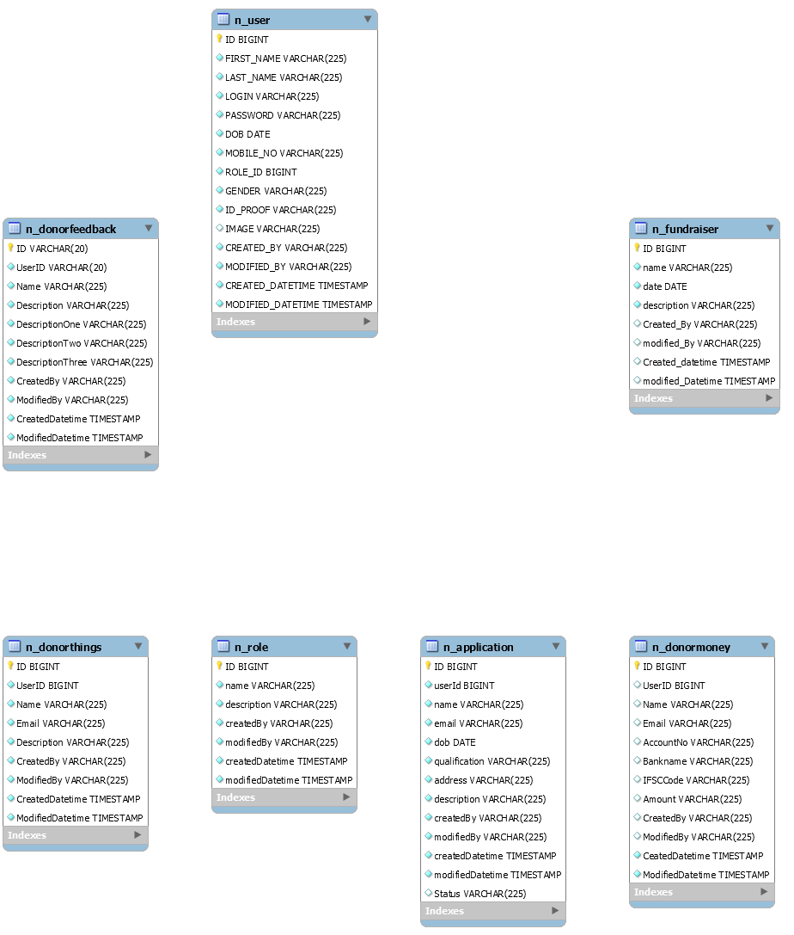

**Data Flow Diagram(DFD)L1**

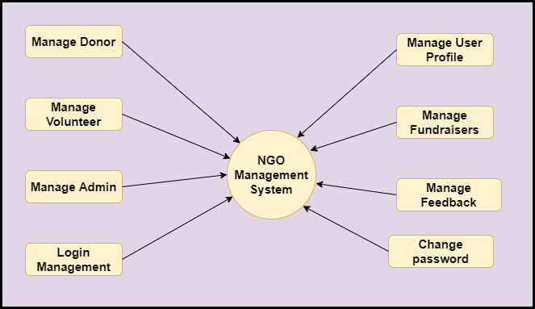

**Data Flow Diagram(DFD)L2**

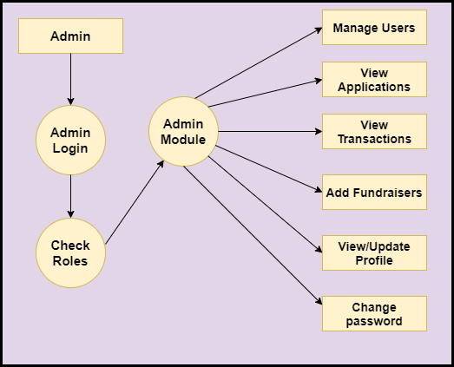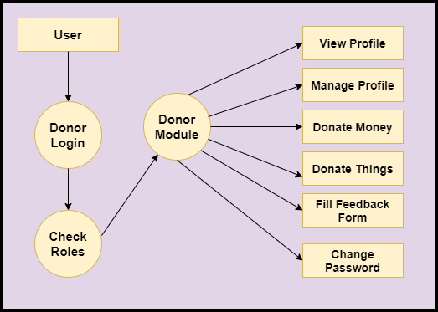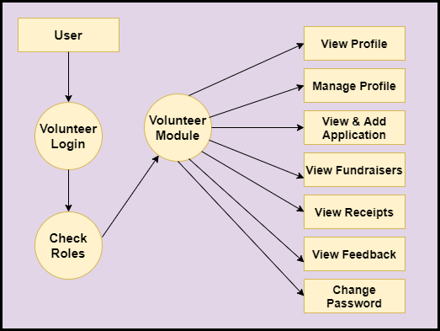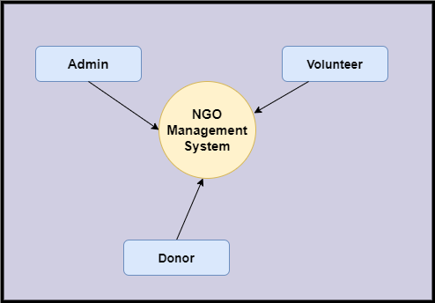

**Functional DFD:**

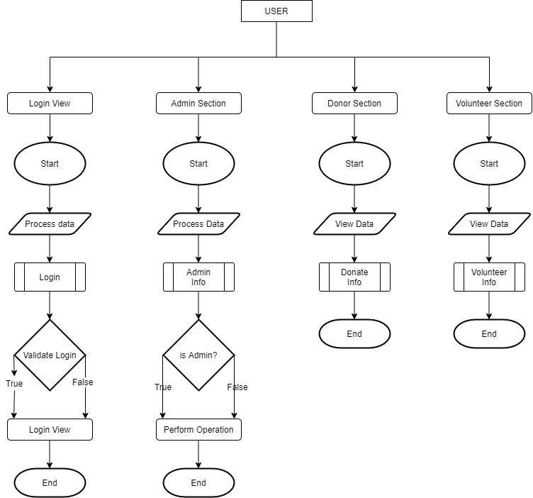

**Feasibility:**

This project will be developed on computer, so first check whether the technology is technically available or not. Now a day’s computer interaction with any job becomes common for any kind of job or work.

And because of increasing usage of Computer, Computer is also available with a variety of hardware. Vendors can fulfill any type of hardware requirement. The whole project is developed by some special tools or by using languages and databases, which are also available in a variety.

Preliminary investigation of a system examines the feasibility of a system that is useful to an organization. It is the first phase of system development.

The main objective of this phase is to identify the current deficiencies in the user’s environment and to determine which existing problem are going to be solve in proposed system and also which new function needs to be added in proposed system.

An important outcome of such preliminary investigation is to determine whether the system that will meet all needed requirements.

Thus, three tests are carried out on the system namely operation, technical and economical.

Any project is beneficial if and only satisfies the organization requirement. For any new system setup, it only meets to be communicated and work the other supporting system.

The new system meets all existing operations since it provides right information at a right time to the right user. A Leigh man can easily operate with the system.

Technical Feasibility examines whether the technology needed is available and if it is available then it feasible to carry out all project activities.

The technical needs of a system include:

* The facility to produce outputs in a given time.
* Ability to process large number of transaction at a particular speed.
* Giving response to users under certain conditions.

The technology needed for our system is mainly:

* Latest version of browsers.
* Any operating system.

These technologies are available which helps to carry out the system efficiently.

Economical feasibility of a system examines whether the finance is available for implementing the new system and whether the money spent is recoverable the satisfaction.

The cost involves is in designing and developing a good investment for the organization.

Thus, hardware requirements used for proposed system are very standard. Moreover, by making use of proposed system to carry out the work speedily will increase and also saves the valuable time of an organization.

In the proposed system the finance is highly required for the installation of the software’s which can also be recovered by implementing a better system.



**Chapter-3**

**Design**

**3.1 Data flow diagram:.**

**System Flow Chart :**



**Data validaton:**

Procedures are designed to detect errors in data at a lower level of detail. Data validations have been integrated in the system in almost every area where there is a possibility for the user to commit errors. The system will not recognize invalid data.

Whenever an invalid data is keyed in, the system immediately prompts the user and the user has to again key in the data and the system will accept the data only if the data is correct. Validations have been integrated where necessary.

The system is designed to be a user friendly one. In other words the system has been designed to communicate effectively with the user. The system has been designed with pop up menus.

**Different Type Of validation :**

* Data type validation;
* Range and constraint validation;
* Code and Cross-reference validation; and
* Structured validation

**Coding**

**DATABASE CONNECTIVITY CODE:**

**UserModel**

**Implementation and Testing :**

**Black-Box Testing**:

Black Box Testing, also known as Behavioral Testing, is a software testing method in which the internal structure/ design/ implementation of the item being tested is not known to the tester. These tests can be functional or non-functional, though usually functional.

This can be following way:

* Input interfacing
* Processing
* Output interfacing



This method is named so because the software program, in the eyes of the tester, is like a black box; inside which one cannot see. This method attempts to find errors in the following categories:

* Incorrect or missing functions
* Interface errors
* Errors in data structures or external database access
* Behavior or performance errors
* Initialization and termination errors

**White-Box Testing:**

White Box Testing ,also known as Clear Box Testing, Open Box Testing, Glass Box Testing, Transparent Box Testing, Code-Based Testing or Structural Testing is a software testing method in which the internal structure/ design/ implementation of the item being tested is known to the tester.

The tester chooses inputs to exercise paths through the code and determines the appropriate outputs. Programming know-how and the implementation knowledge is essential.

White box testing is testing beyond the user interface and into the nitty-gritty of a system.

This method is named so because the software program, in the eyes of the tester, is like a white/ transparent box; inside which one clearly sees.

**Screen Snapshot**

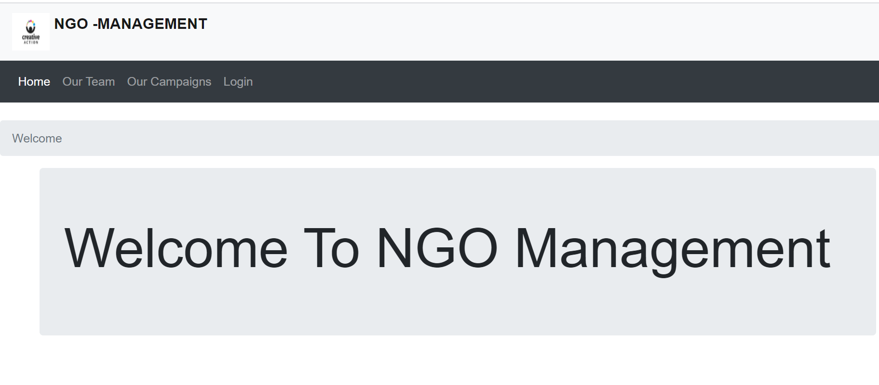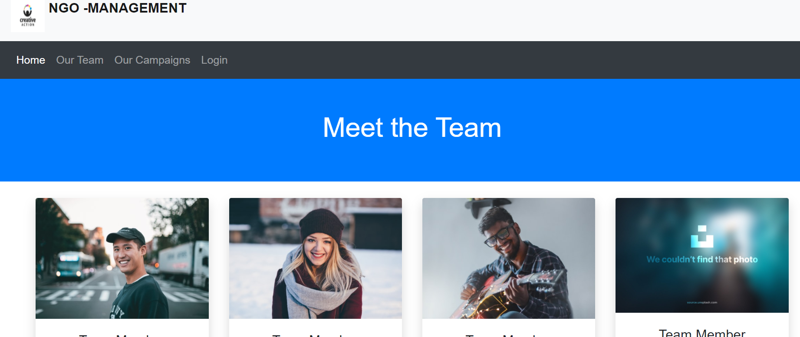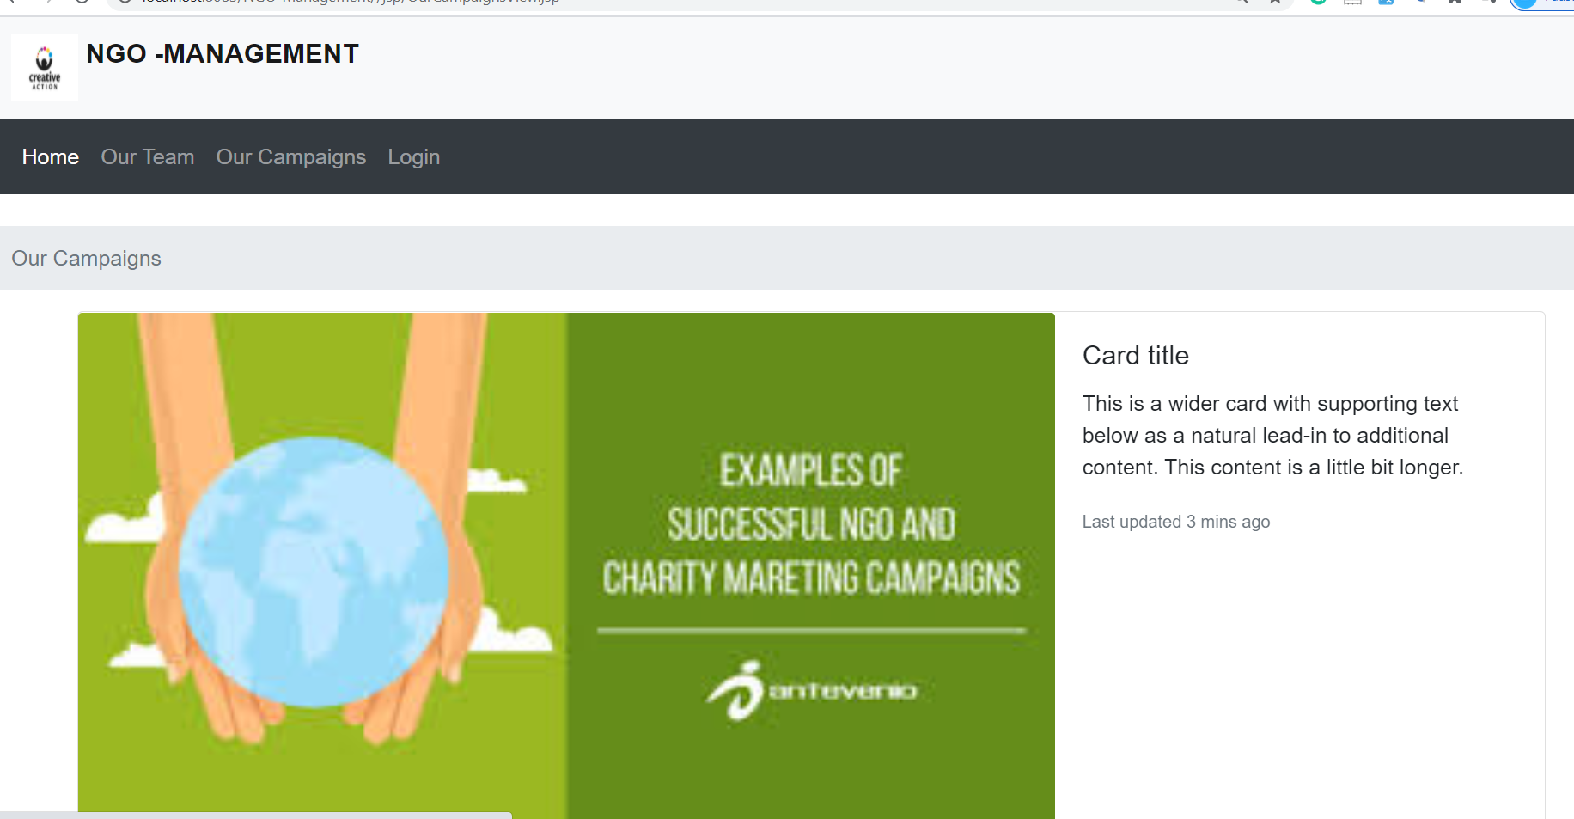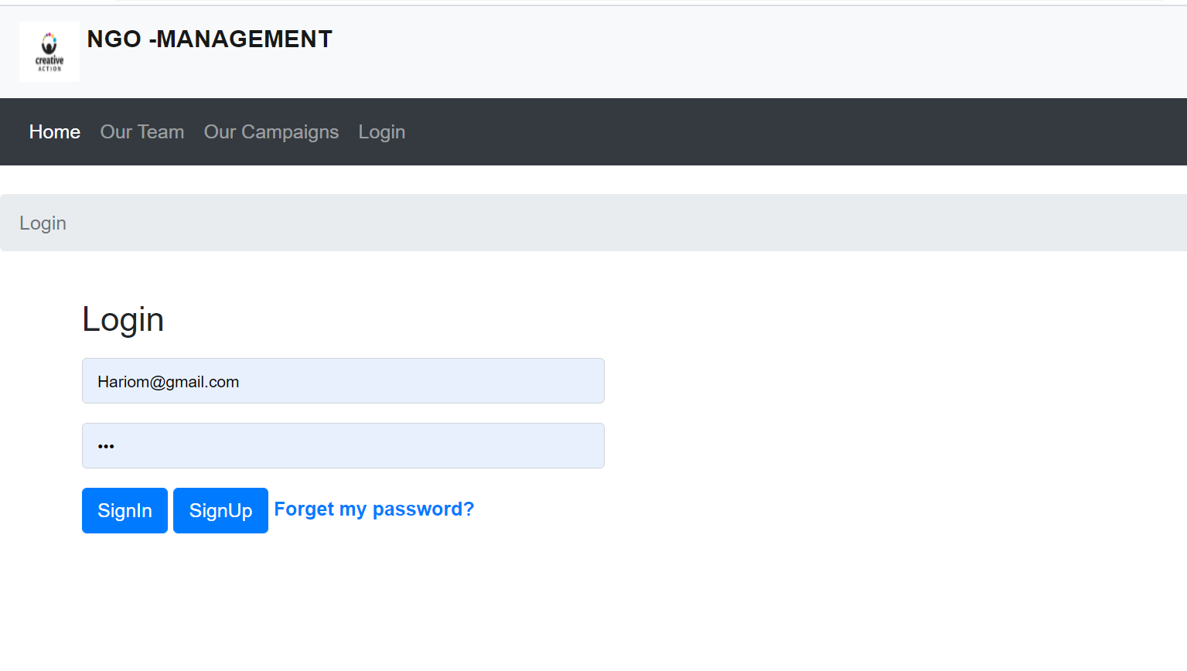

**Limitations and Future Application of the Project**

**Futures Enhancement :**

* In future we can expand this project to add more modules.
* Software can be accessed through internet also.

**Limitation :**

* In this system SMS facility is not available.
* In this system online payment is not available.

**Conclusion:**

This website provides a computerized version of library management system which will benefit the students as well as the staff of the library. It makes entire process online where student can search books, staff can generate reports and do book transactions. It also has a facility for student login where student can login and can see status of books issued as well request for book or give some suggestions. It has a facility of teacher’s login where teachers can add lectures notes and also give necessary suggestion to library and also add info about workshops or events happening in our college or nearby college in the online notice board. There is a future scope of this facility that many more features such as online lectures video tutorials can be added by teachers as well as online assignments submission facility , a feature Of group chat where students can discuss various issues of engineering can be added to this project thus making it more interactive more user friendly and project which fulfills each users need in the best way possible

**Bibliography / References**

**Biblography/ Reference Sites :**

1. http://www.lisbdnet.com/definition-of-library-managemen/
2. <https://www.codedec.com/>